Thomas Jones – CS 5567-0002 – Project 2

## Approach

The ultimate purpose of this project was to compare the performance of fully connected vs CNN based topologies. An experimental framework was selected where;

1. Baseline models were constructed where the maximum epoch count and learning rates were explored for both datasets. The reduced test accuracy of the fashion dataset shows the challenge of the additional complexity. See page 2 for heatmaps.
2. Based on the initial model results a target learning rate and epoch count were selected. This selection helped to limit the search space. See pages 3-X for data and diagrams.
3. Using Keras, a convolutional model was constructed. Initially, a small search space was selected using the Keras-Tuner hyperparameter library. This library reduced the code complexity found when iterating over, capturing, and reporting on results. The first execution used a GridSearch to walk through a limited search space.
4. The hyper-parameter search space was then expanded and a BayesianOptimization tuner used.

## Observations

### Fully Connected Networks

As seen from the heatmaps, the default learning rate for the Adam optimizer provided a reasonable performance. It was also found that limiting the epoch count to 7 instead of the proposed 25-50 also provided acceptable results. ***For both datasets, the target minimum accuracy was achieved with the provided topology*, *32/16, Adam optimizer with a learning rate of 0.002***. Further topologies were explored as well though as the results show, the best across the explored the best MNIST accuracy was **96%** and the best Fashion_MNIST accuracy was **88%**.

### CNN Results

Heatmaps of achieved accuracy as a function of Epochs and Learning Rate. Two hidden layers were used of 32 and 16 neurons respectively. The Adam optimizer with various learning rates were iterated over to increasing number of epochs. This gives us a view of how many epochs and what learning rate to select for further tests of the topologies.

*MNIST Accuracy vs Learning Rate vs Epochs*

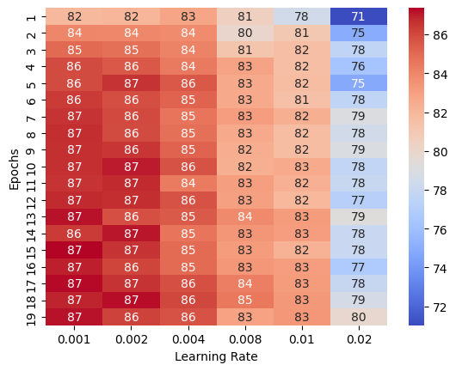

*Fashion_MNIST Accuracy vs Learning Rate vs Epochs*